Name:_________________________________________________ Date:________________ Period: _______

Circuits – Quiz 2B (15 Points) REGULAR Mr. Werman
Multiple Choice I: Write the letter of the best answer in the space provided. (1 point each)

______1) Which of the following configurations will light the bulb?
a) 1, 3, 4, and 5 c) 2, 3, and 5
b) 1, 3, and 4 d) All Five







1 2 3 4 5






______2) A toaster (10 Ω), coffee maker (12 Ω), microwave (40 Ω), and blender (50 Ω) are plugged in and receiving 120 V. Which appliance will draw the most power when running?
a) toaster c) microwave
b) coffee maker d) blender

______3) Several resistors of varying values are wired in series. What is true about this circuit?
a) The sum of the currents through each resistor will equal the total circuit current.
b) The total circuit current will be the same as the current through any one resistor.
c) The voltage across any resistor is the same as the voltage of the power supply.
d) The current will be slowest through the largest resistor and fastest through the lowest resistor.

______4) Several resistors of varying values are wired in parallel. What is true about this circuit?
a) The current through each resistor will be the same as the total circuit current from the supply.
b) The voltage across each resistor will be the same.
c) The addition of each resistor to the circuit increases the overall resistance of the circuit.
d) The voltages across each resistor add up to the total voltage from the power supply.




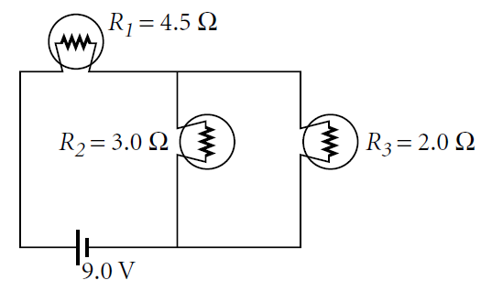
______5) Three bulbs are wired as shown in Figure A. Which bulb would need
Bulb 2
Bulb 1
Bulb 3
to burn out to cause all of the others to go out?
a) Bulb 1 c) Bulb 3
b) Bulb 2 d) No single bulb will cause all to go out

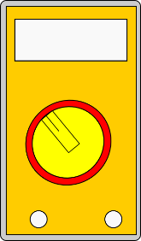
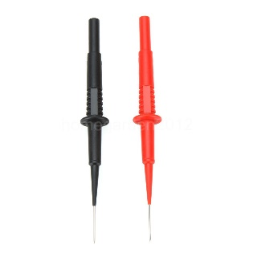
6) The following items are on the table in the physics room. Draw wires to properly connect the lightbulb so that it turns on. Include the ammeter in the circuit to read the current and connect the leads of the Voltmeter to measure the voltage across the lightbulb. Determine the value that would be read on the ammeter in this circuit. Include units. (5 points)
3.0 V

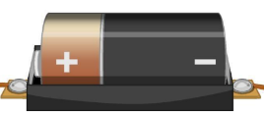
3.0 V

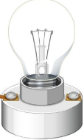
10 Ω

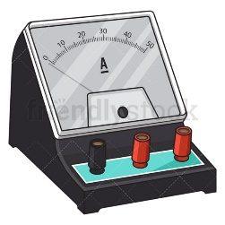

__________________ (Ammeter Reading)

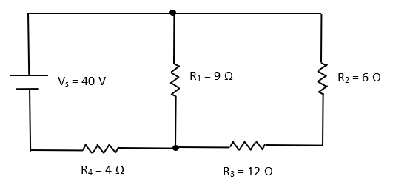
7) What is the Equivalent/Total resistance of this circuit? (5 Points)

